Travis Grimmond

Analysis and Design Unit

A&D 1

Case Diagram

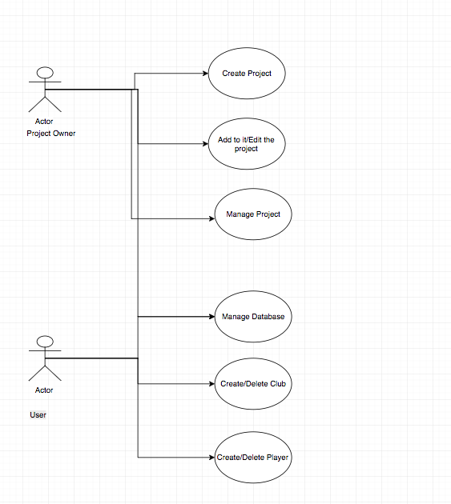

A&D 2

Class Diagram

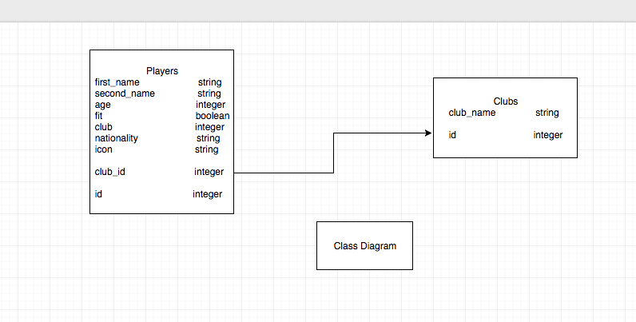

A&D 3

Object Diagram

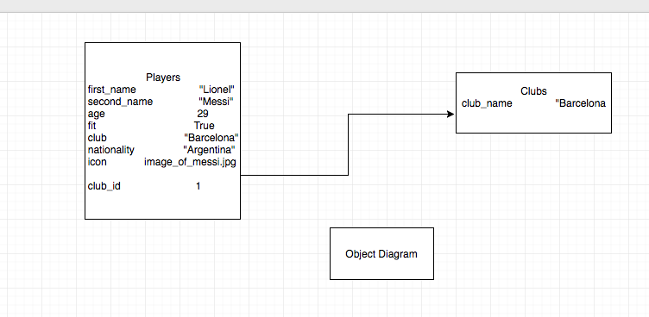

A&D 4

Activity Diagram

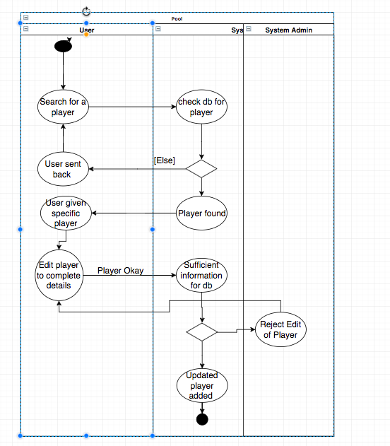

A&D 5

Inheritance Diagram

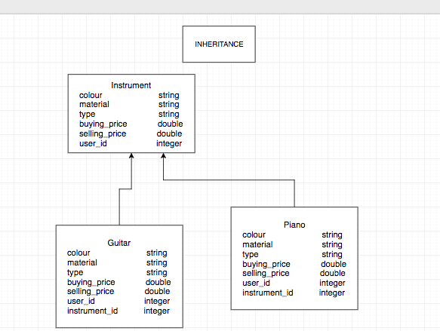

A&D 6

Implementations Constraints plan

